**Ex No: 5 Date:**

**RECOGNIZE AN ARITHMETIC EXPRESSION USING LEX AND YACC**

**AIM:**

To check whether the arithmetic expression using lex and yacc tool.

**ALGORITHM:**

* Using the flex tool, create lex and yacc files.
* In the C include section define the header files required.
* In the rules section define the REGEX expressions along with proper definitions.
* In the user defined section define yywrap() function.
* Declare the yacc file inside it in the C definitions section declare the header files required along with an integer variable valid with value assigned as 1.
* In the Yacc declarations declare the format token num id op.
* In the grammar rules section if the starting string is followed by assigning operator or identifier or number or operator followed by a number or open parenthesis followed by an identifier. The x could be an operator followed by an identifier or operator or no operator then declare that as valid expressions by making the valid stay in 1 itself.
* In the user definition section if the valid is 0 print as Invalid expression in yyerror() and define the main function.

**LEX AND YACC WORKING :**

Parser generator:

* Takes a specification for a context-free grammar.
* Produces code for a parser.

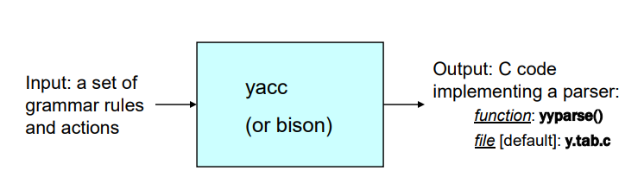

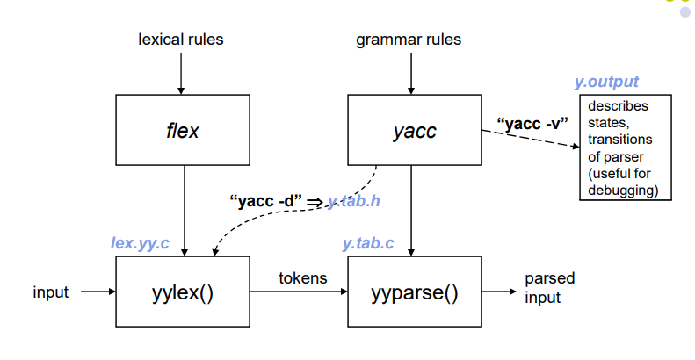

**PROGRAM:**

**validexp.l:**

%{

#include<stdio.h>

#include "y.tab.h"

%}

%%

[a-zA-Z]+ return VARIABLE;

[0-9]+ return NUMBER;

[\t] ;

[\n] return 0;

. return yytext[0];

%%

int yywrap()

{

return 1;

}

**validexp.y:**

%{

    #include<stdio.h>

%}

%token NUMBER

%token VARIABLE

%left '+' '-'

%left '*' '/' '%'

%left '(' ')'

%%

S: VARIABLE'='E {

       printf("\nEntered arithmetic expression is Valid\n\n");

       return 0;

     }

E:E'+'E

 |E'-'E

 |E'*'E

 |E'/'E

 |E'%'E

 |'('E')'

 | NUMBER

 | VARIABLE

;

%%

void main()

{

   printf("\nEnter Any Arithmetic Expression which can have operations Addition, Subtraction, Multiplication, Divison, Modulus and Round brackets:\n");

   yyparse();

}

void yyerror()

{

   printf("\nEntered arithmetic expression is Invalid\n\n");

}

**OUTPUT:**

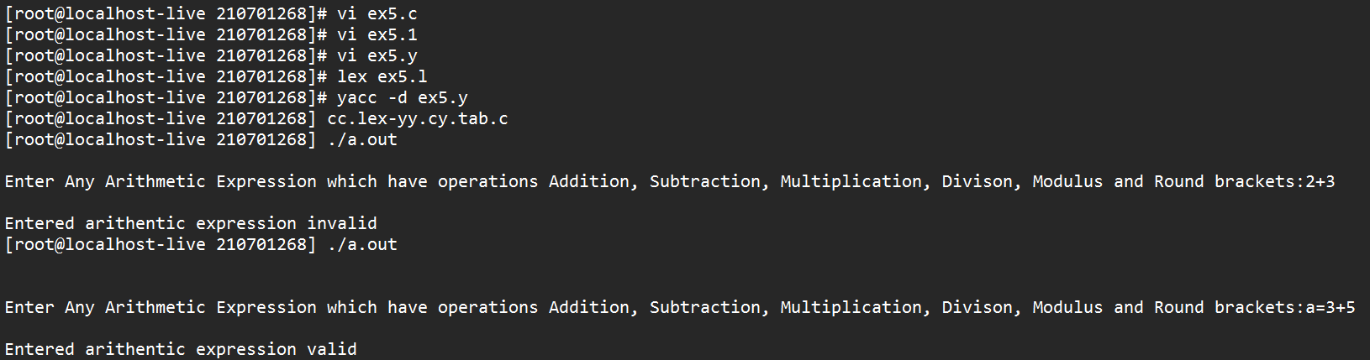

**RESULT:**